**Practical: 2**

**Aim: Java RMI Programming.**

1. **Implementation of “Hello World” Service using Java RMI.**

**Code:**

/* SampleServer.java */

import java.rmi.*;

public interface SampleServer extends Remote

{

    public String printHello() throws RemoteException;

}

**/\*** SampleServerImpl.java **\*/**

import java.rmi.*;

import java.rmi.server.*;

public class SampleServerImpl extends UnicastRemoteObject implements SampleServer

{

    SampleServerImpl() throws RemoteException

    {

        super();

    }

    public static void main(String args[])

    {

        try

        {

            SampleServerImpl Server = new SampleServerImpl();

            Naming.rebind("SAMPLE-SERVER" , Server);

            System.out.println("Server waiting.....");

        }

        catch (java.net.MalformedURLException me)

        {

            System.out.println("Malformed URL: " + me.toString());

        }

        catch (RemoteException re)

        {

            System.out.println("Remote exception: " + re.toString());

        }

    }

    public String printHello() throws RemoteException

    {

        return "Sample Hello World";

    }

}

**/\*** SampleClient.java **\*/**

import java.rmi.*;

public class SampleClient

{

    public static void main(String[]  args)

    {

        try

        {

            System.out.println("Security Manager loaded");

            String url = "//localhost/SAMPLE-SERVER";

            SampleServer remoteObject = (SampleServer)Naming.lookup(url);

            System.out.println("Got remote object\n");

            System.out.println("Print Hello: "+remoteObject.printHello());

        }

        catch (RemoteException exc)

        {

            System.out.println("Error in lookup: " + exc.toString());

        }

        catch (java.net.MalformedURLException exc)

        {

            System.out.println("Malformed URL: " + exc.toString());

        }

        catch (java.rmi.NotBoundException exc)

        {

            System.out.println("NotBound: " + exc.toString());

        }

    }

}

**Output:**

Compile Code:

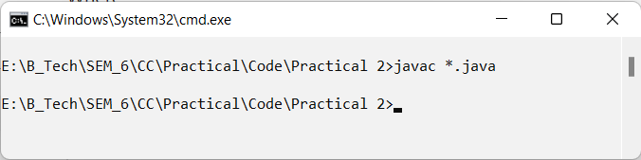

Start RMI:

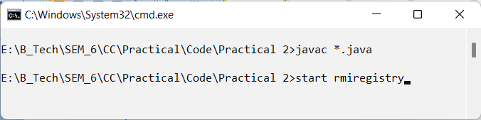

Run SampleServerImpl.java

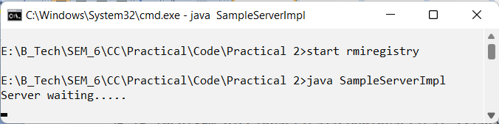

Run SampleClient.java

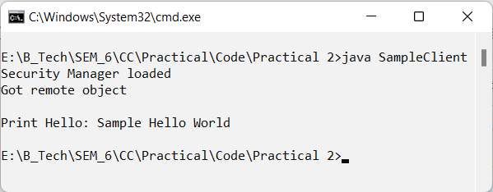

1. **Implementation of “Calculator” Service (Add, Sub, Mul, Div) using Java RMI.**

**Code:**

**/\*** SampleServer.java **\*/**

import java.rmi.*;

public interface SampleServer extends Remote

{

    public double sum(double a, double b) throws RemoteException;

    public double sub(double a, double b) throws RemoteException;

    public double mul(double a, double b) throws RemoteException;

    public double div(double a, double b) throws RemoteException;

}

**/\*** SampleServerImpl.java **\*/**

import java.rmi.*;

import java.rmi.server.*;

public class SampleServerImpl extends UnicastRemoteObject implements SampleServer

{

    SampleServerImpl() throws RemoteException

    {

        super();

    }

    public static void main(String args[])

    {

        try

        {

            SampleServerImpl Server = new SampleServerImpl();

            Naming.rebind("SAMPLE-SERVER" , Server);

            System.out.println("Server waiting.....");

        }

        catch (java.net.MalformedURLException me)

        {

            System.out.println("Malformed URL: " + me.toString());

        }

        catch (RemoteException re)

        {

            System.out.println("Remote exception: " + re.toString());

        }

    }

    @Override

    public double sum(double a, double b) throws RemoteException {

        return a+b;

    }

    @Override

    public double sub(double a, double b) throws RemoteException {

        return a-b;

    }

    @Override

    public double mul(double a, double b) throws RemoteException {

        return a*b;

    }

    @Override

    public double div(double a, double b) throws RemoteException {

        if(b!=0)

        {

            return a/b;

        }

        else{

            return 0;

        }

    }

}

**/\*** SampleClient.java **\*/**

import java.rmi.*;

import java.util.*;

public class SampleClient

{

    public static void main(String[]  args)

    {

        double num1, num2;

        int sel;

        String res;

        Scanner sc= new Scanner(System.in);

        try

        {

            System.out.println("Security Manager loaded");

            String url = "//localhost/SAMPLE-SERVER";

            SampleServer remoteObject = (SampleServer)Naming.lookup(url);

            System.out.println("Got remote object\n");

            System.out.println("1. Addition");

            System.out.println("2. Subtraction");

            System.out.println("3. Multiplication");

            System.out.println("4. Division\n");

            System.out.print("Select Options: ");

            sel=sc.nextInt();

            System.out.print("Enter Num1: ");

            num1=sc.nextDouble();

            System.out.print("Enter Num2: ");

            num2=sc.nextDouble();

            switch(sel)

            {

                case 1: res = String.format("Addition of %f + %f: %f",num1,

num2,remoteObject.sum(num1, num2));

                        System.out.println(res);

                        break;

                case 2: res = String.format("Subtraction of %f - %f: %f",num1,

num2,remoteObject.sub(num1, num2));

                        System.out.println(res);

                        break;

                case 3: res = String.format("Multiplication of %f * %f: %f",num1,

num2,remoteObject.mul(num1, num2));

                        System.out.println(res);

                        break;

                case 4: res = String.format("Division of %f / %f: %f",num1,

num2,remoteObject.div(num1, num2));

                        System.out.println(res);

                        break;

                default: System.out.println("Invalid Selection! Retry");

            }

        }

        catch (RemoteException exc)

        {

            System.out.println("Error in lookup: " + exc.toString());

        }

        catch (java.net.MalformedURLException exc)

        {

            System.out.println("Malformed URL: " + exc.toString());

        }

        catch (java.rmi.NotBoundException exc)

        {

            System.out.println("NotBound: " + exc.toString());

        }

        sc.close();

    }

}

**Output:**

Compile Code:

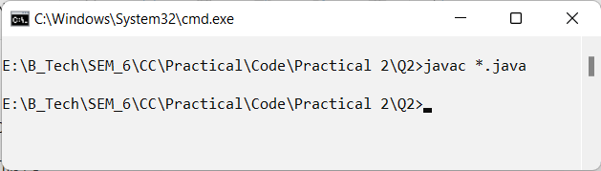

Start RMI:

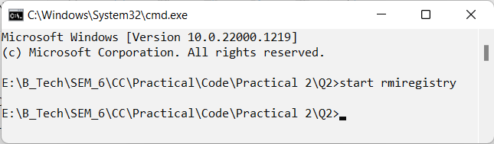

Run SampleServerImpl.java

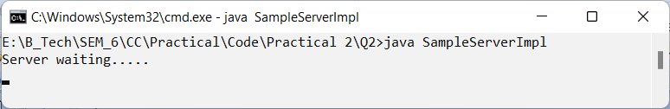

Run SampleClient.java

